Description of the Product
20 HP ELECTRIC OUTBOARD MOTOR

SEAGÖ SE20 series is an electric outboard motor has a rated voltage of 96V, and the maximum power is 15 kW. Compared to the existing gasoline models, the electric outboard is quieter and more environmentally friendly because they run on electricity instead of fuel. Additionally, we use Permanent Magnet Synchronous Motors, which have reduced noise, extended lifespan, increased efficiency and require less maintenance.
Relevant Boat Class
Small vessels of various materials including inflatable boats, wooden boats, FRP boats, plastic boats and similar, with lengths ranging from 3.6 to 7.0 Metres, are a good fit for the electric 20-horsepower outboard motor.
Recommended Battery
For this Model, 96V 200 AH or 96V 230 AH LiFePO4 – Lithium Ferrous Phosphate battery packs can be utilized
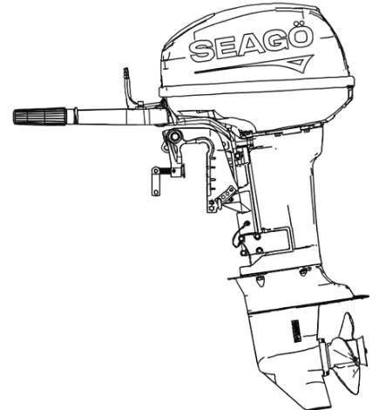
Model Options
SE20BS/ SE20BL– Tiller Control Short / Long Shaft
SE20FS/ SE20FL – Remote Control Short/Long Shaft

Specifications

Product Model | SE20 Series
Rated Power | 15 kW
Rated Voltage | 96 V
Motor Type | PMSM
Sensor Type | Magnetic Encoder
Steering System | Tiller / Remote Control
Maximum Speed | 5800 RPM
Gear Ratio | 2.08
Transom Height | S:440mm / L:570mm
Weight {Kg} | S:45 Kg / L: 48 Kg
Cooling System | Water Cooled
Gear Position | Forward/Neutral/ Reverse

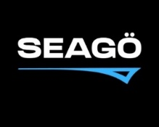
www.seago.in sales@seago.in +91-8606366633
20 HP ELECTRIC OUTBOARD MOTOR

